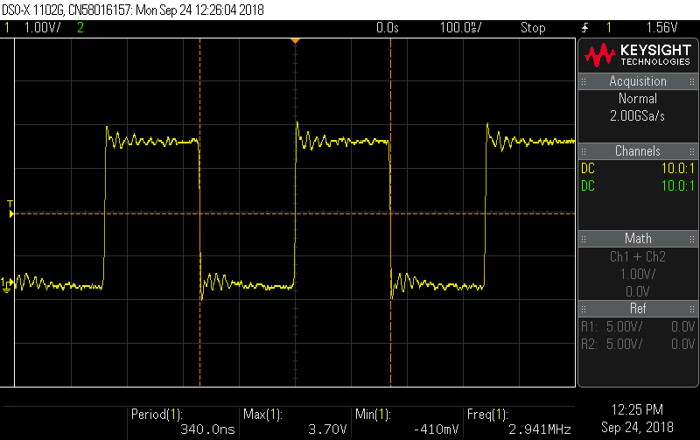

Before (in homework 2) I was only see approximately 401us for the minimum period whereas as you can see above, with mmap, I got down to 340ns. This is magnitudes faster.